1. 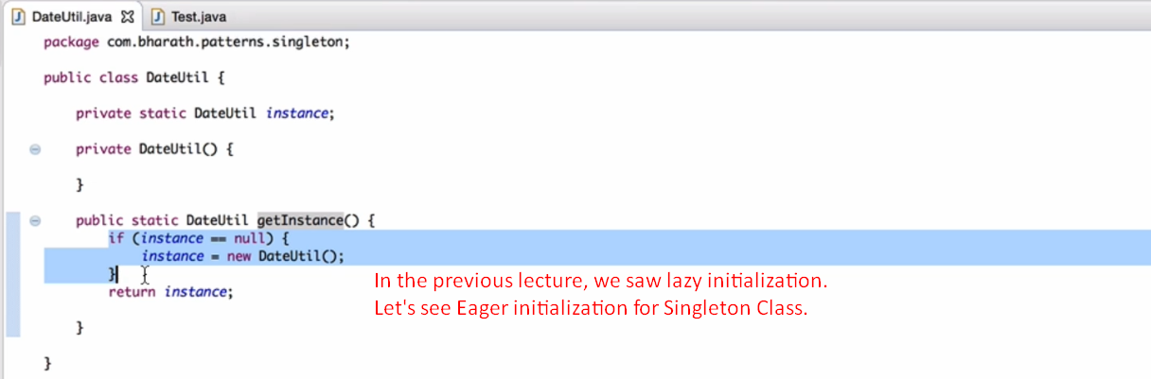
2. 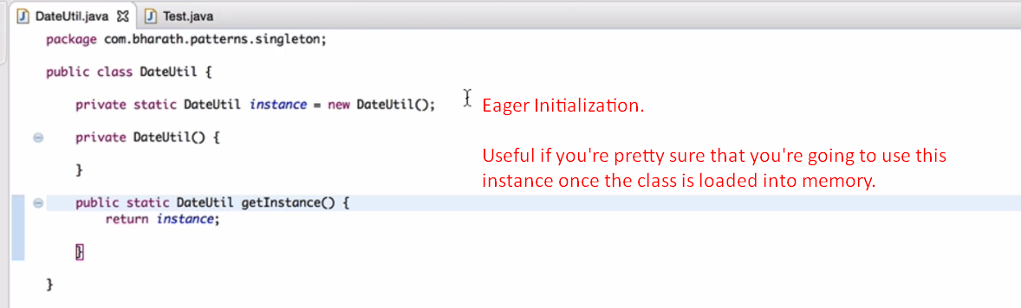 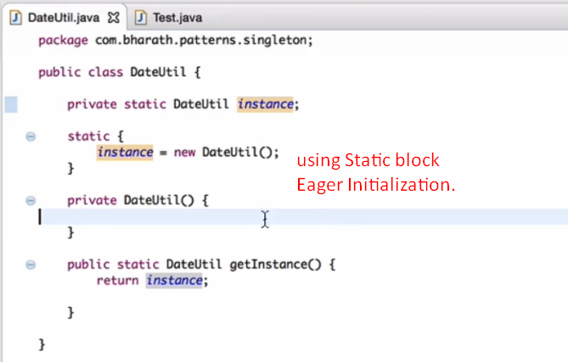
3. **NOTE**: Lazy initialization is preferred.